Upstart
How China Became a Great Power
Appendix: XXXX

Oriana Skylar Mastro

Chinese Swap Agreements

Country and Year Established | Amount, RMB billions
Albania, 2018 | ¥2
Argentina, 2020 | ¥130
Australia, 2012 | ¥200
Belarus, 2015 | ¥7
Brazil, 2013 | ¥190
Canada, 2021 | ¥200
Chile, 2018 | ¥50
Egypt, 2016 | ¥18
Euro zone, 2013 | ¥350
Hong Kong SAR, 2022 | ¥800
Hungary, 2020 | ¥20
Iceland, 2010 | ¥4
Indonesia, 2022 | ¥250
Japan, 2018 | ¥200
Kazakhstan, 2018 | ¥7
Kyrgyztan, 2014 | ¥3
Lao PDR, 2020 | ¥6
Macao SAR, 2019 | ¥30
Malaysia, 2018 | ¥180
Mongolia, 2020 | ¥15
Nepal, 2014 | Unclear
New Zealand, 2020 | ¥25.00
Nigeria, 2018 | ¥15.00
Pakistan, 2018 | ¥20.00
Qatar, 2014 | ¥35.00
Russia, 2020 | ¥150.00
Singapore, 2019 | ¥300.00
South Africa, 2018 | ¥30.00
South Korea, 2020 | ¥400.00
Sri Lanka, 2021 | ¥10.00
Suriname, 2015 | ¥1.00
Switzerland, 2014 | ¥150.00
Thailand, 2021 | ¥70.00
Turkey, 2021 | ¥35.00
UAE, 2012 | ¥35.00
United Kingdom, 2018 | ¥350.00
Ukraine, 2018 | ¥15.00
Uzbekistan, 2011 | ¥0.70

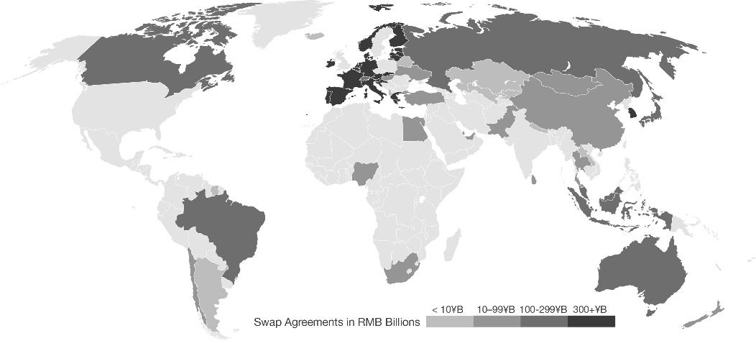
Map of China’s Currency Swap Agreements as 2022

