Upstart
How China Became a Great Power
Appendix: US Currency Swap Agreements

Oriana Skylar Mastro

Currency Swap Agreements

Current and Past US Swap Agreements

Country, Date Established | Amount, USD
Australia, 2020 (expired December 2021) | $60 billion
Brazil, 2020 (expired December 2021) | $60 billion
Canada, 2010; 2013 made a permanent standing arrangement | Unlimited
Denmark, 2020 (expired December 2021) | $30 billion
European Union, 2010; 2013 made a permanent standing arrangement | Unlimited
Japan, 2011; 2013 made a permanent standing arrangement | Unlimited
Mexico, 1994 (North American Framework Agreement) | $3 billion; 2018 increased to $9 billion
Mexico, 2020 (expired December 2021) | $60 billion
New Zealand, 2020 (expired December 2021) | $30 billion
Norway, 2020 (expired December 2021) | $30 billion
Singapore, 2020 (expired December 2021) | $60 billion
South Korea, 2020 (expired December 2021) | $60 billion
Sweden, 2020 (expired December 2021) | $60 billion
Switzerland, 2010; 2013 made a permanent standing arrangement | Unlimited
United Kingdom, 2011; 2013 made a permanent standing arrangement | Unlimited
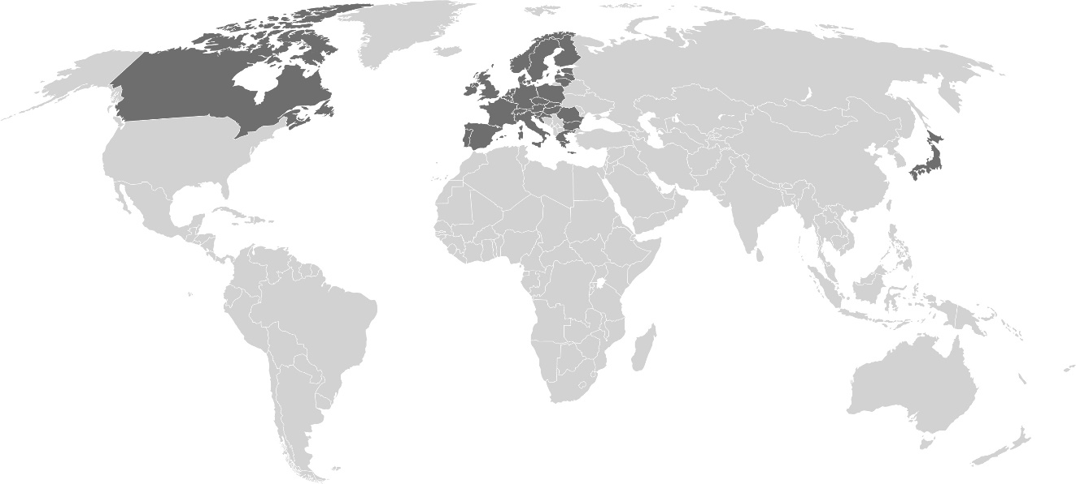
Map of US Swap Agreements with Partner Countries

